**NAME:Sharvayu Zade**

**PRN:23070521135**

**SEC:B(B2)**

**Introduction to PL/SQL Conditions**

In PL/SQL, conditions allow decision-making in programs. The two main types of conditional statements are:

**IF-THEN**

**IF-THEN-ELSE**

**IF-THEN-ELSIF-ELSE**

**CASE Statement**

**IF-THEN Statement**

Executes a block of code if the condition is TRUE.

**Example: Check if a number is positive**

SET SERVEROUTPUT ON;

DECLARE

num NUMBER := 10;

BEGIN

IF num > 0 THEN

DBMS_OUTPUT.PUT_LINE('The number is positive.');

END IF;

END;

/ 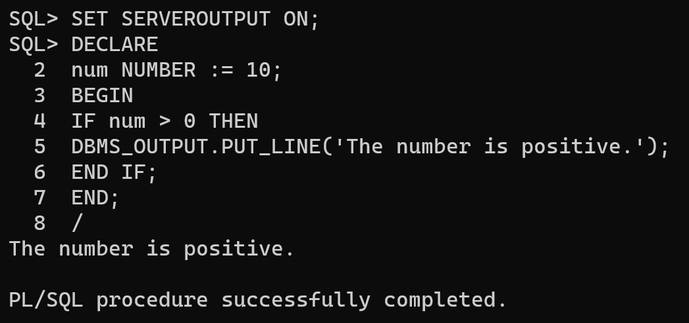

**IF-THEN-ELSE Statement**

Executes one block if the condition is TRUE, otherwise executes another block. **Example: Check if a number is even or odd**

SET SERVEROUTPUT ON;

DECLARE

num NUMBER := 7;

BEGIN

IF MOD(num, 2) = 0 THEN

DBMS_OUTPUT.PUT_LINE('Even number');

ELSE

DBMS_OUTPUT.PUT_LINE('Odd number');

END IF;

END;

/ 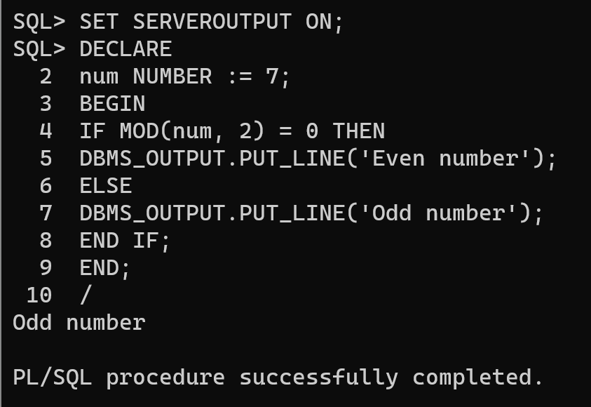

**IF-THEN-ELSIF-ELSE Statement**

Check multiple conditions one by one.

**Example: Check if a number is positive, negative, or zero**

SET SERVEROUTPUT ON;

DECLARE

num NUMBER := -5;

BEGIN

IF num > 0 THEN

DBMS_OUTPUT.PUT_LINE('Positive number');

ELSIF num < 0 THEN

DBMS_OUTPUT.PUT_LINE('Negative number');

ELSE

DBMS_OUTPUT.PUT_LINE('Zero');

END IF;

END;

/ 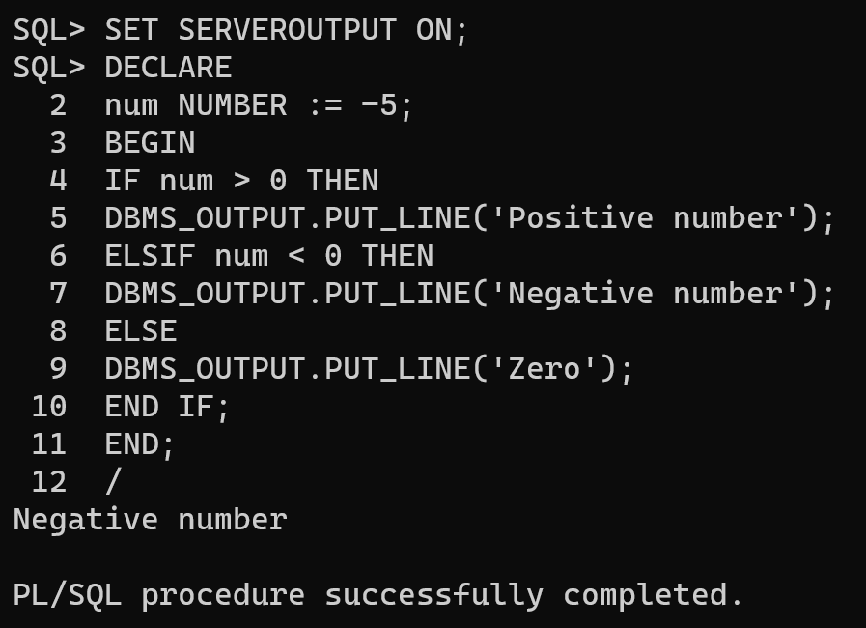

**CASE Statement**

The CASE statement is used to handle multiple conditions more efficiently. **Example: Grade Calculation Using CASE**

SET SERVEROUTPUT ON;

DECLARE

marks NUMBER := 85;

grade VARCHAR2(10);

BEGIN

grade := CASE

WHEN marks >= 90 THEN 'A'

WHEN marks >= 80 THEN 'B'

WHEN marks >= 70 THEN 'C'

ELSE 'Fail'

END;

DBMS_OUTPUT.PUT_LINE('Grade: ' || grade);

END;

/ 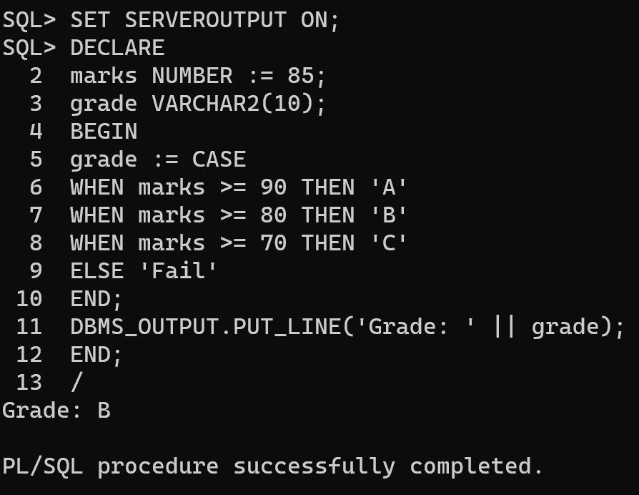

**Simple Tasks for Practice**

1. Write a PL/SQL program to check whether a number is **divisible by 5**. 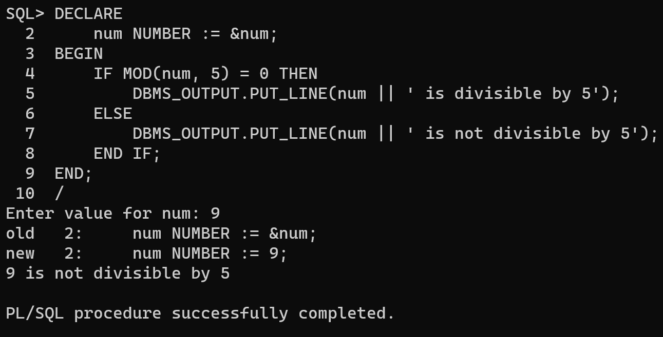

2. Modify the **grade program** to include more conditions (e.g., 60-70 for **D**, below 60 for **F**). 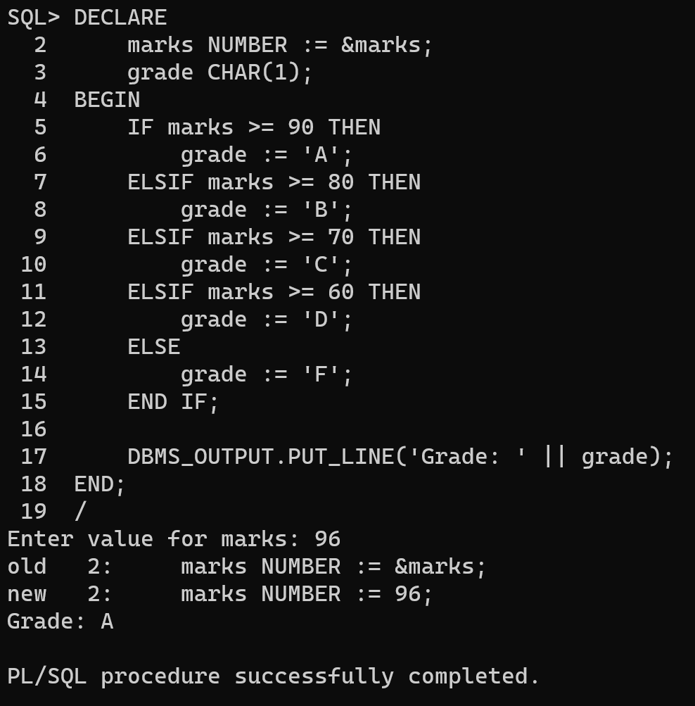

3. Write a **CASE statement** to display the day of the week based on a number input (1 = Monday, 2 = Tuesday, etc.).

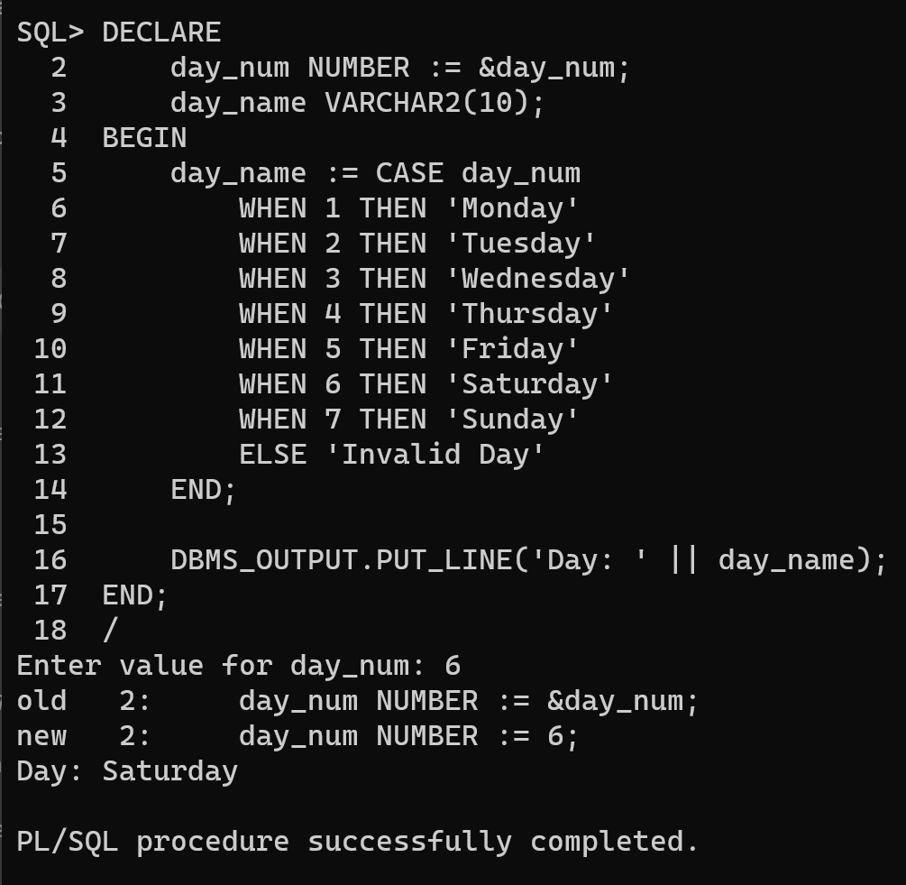

4. Create a program that **checks the largest of three numbers** using IF-THEN-ELSIF.